ICS3C1 Graphics Assignment

- House.py
Write a program do draw a house similar to the one below. Your program should make use of the necessary drawing commands to properly display the features shown.

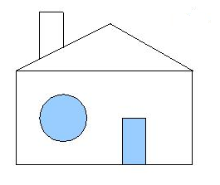
A correct representation of the picture will receive a level 3+. Adding additional features will improve your mark. At least two additional enhancements must be made. Enhancements may include:
- A landscape of the ground and sky (2 different colored rectangles will do)
- A doorknob
- An additional Window
- Crossbars for the Window
- A crescent moon

- Maze.py
Write a program to display a maze similar to the one below. The maze below will receive a 3+. Add a more complicated version of your maze to receive a 4+.

